By: Kim Foster, APR

Contributors: Danielle Anderson, Byway Program Administrator - A1A Scenic & Historic Coastal Byway, Inc, and Christina Parrish Stone, Executive Director - St. Johns Cultural Council

[A1A Scenic & Historic Coastal Byway - National Scenic Byway Foundation (nsbfoundation.com)](https://nsbfoundation.com/blog/a1a-scenic-historic-coastal-byway/)

**Explore the AIA Scenic & Historic Coastal Byway – The Ultimate 72-Mile Florida Road Trip**

Take a breath.  
Exhale.  
Relax.  
Escape the indoors and soak in the beauty that is [A1A](https://scenica1a.org/).

[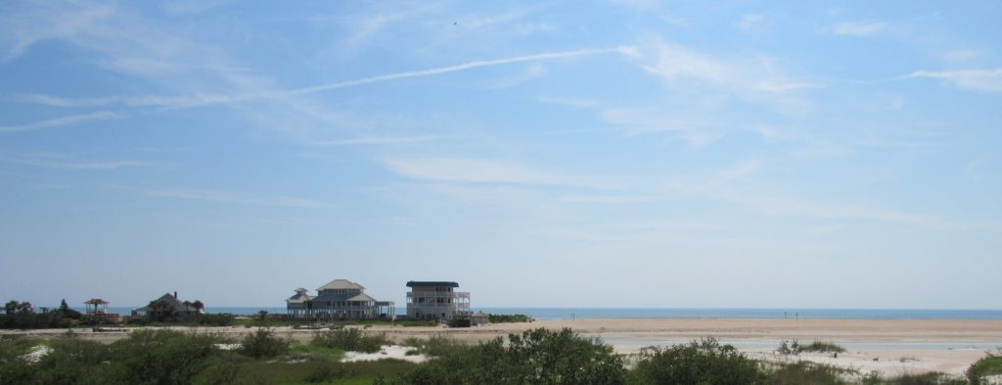](https://nsbfoundation.com/wp-content/uploads/2022/02/Summer-Haven-2.jpg)

Summer Haven

While the rebirth and exploration of [America’s Byways](http://www.travelbyways.com/) may be a new experience for many over the past couple of years, it is a way of life for those who know and love Florida’s [A1A Scenic & Historic Coastal Byway](https://scenica1a.org/).  Here, you not only find beauty on the open road coupled with front-row ocean views but also five centuries of history in our nation’s oldest city.  This legendary backdrop connects 72 miles of state and national parks, stunning beaches, and coastal recreation with unparalleled culinary experiences and unique attractions filled with the arts, history, and culture of Florida’s Historic Coast.

**About the AIA Scenic & Historic Coastal Byway**

[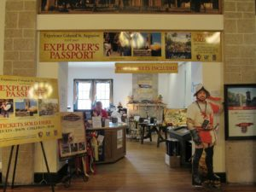](https://nsbfoundation.com/wp-content/uploads/2022/02/St-Augustine-Visitors-Center-3.jpg)

St. Augustine Visitors Center

[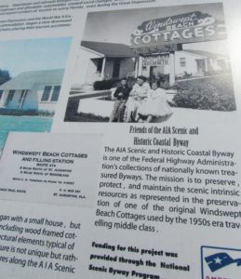](https://nsbfoundation.com/wp-content/uploads/2022/02/Windswept-Acres-4.jpg)

Windswept Acres

Whether you’re an experienced wanderer or just love a good road trip, few states can match the variety and scenic beauty of Northeast Florida.  Designated as the state’s second All-American Road in 2021, the A1A Scenic & Historic Coastal Byway offers you the opportunity to walk the streets of the first continuously occupied settlement in the nation (est.1565). A good portion of the byway travels along barrier islands situated between the ocean and the Intracoastal Waterway, making it one of the most scenic roads in the entire state. The vibe along the byway is as diverse as its history, ranging from luxury oceanfront experiences in Ponte Vedra and the vibrant cultural scene of St. Augustine to the funky, old-Florida feel of Vilano Beach.  Their authenticity draws you in to explore, dine, stay and play.

**Where is the AIA Scenic & Historic Coastal Byway?  How do I get there?**

Nestled along the coastline of Northeast Florida, the A1A Scenic Byway’s northern gateway begins in St. Johns County.  From there, the byway travels south bisecting the seaside luxury and golf mecca of Ponte Vedra Beach before weaving through the pristine Guana Tolomato Matanzas National Estuarine Research Reserve (GTM NERR).  Drive on through Vilano Beach and America’s oldest city, St. Augustine. Travel 14 miles south to Matanzas Inlet (St. Johns County’s southern border), then continue on through Flagler County, with the southern terminus of the Byway in Flagler Beach just past Gamble Rogers Memorial State Park.

The AIA Scenic & Historic Coastal Byway is easy to get to by vehicle and runs parallel to I-95.  The byway is convenient for air travelers as well. Arriving at the Jacksonville International Airport, the byway’s northern gateway is just 40 minutes south in Ponte Vedra, and even closer to St. Augustine’s Northeast Florida Regional Airport.

**What’s the weather like?**

Along A1A, winters are moderate and summers cooler than other parts of Florida.  With abundant sunshine and average daily temperatures of 70 degrees Fahrenheit, there’s never a bad time to visit the A1A Scenic & Historic Coastal Byway.

**How long do I need to drive A1A?**

How long you will explore is a tough decision!  You can drive this portion of A1A as quickly as 2 hours, or you can spend a week or more exploring our many historic attractions and uncrowded beaches, indulging in local and international cuisine including fresh seafood year-round, and relaxing in a variety of accommodations.  For a little planning help, we recommend you check out the itineraries at HistoricCoastCulture.com and the  [A1A Scenic Byway Mobi Tour](https://travelstorys.com/tours/a1a-scenic-byway).

[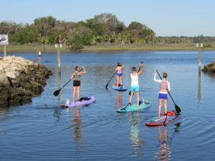](https://nsbfoundation.com/wp-content/uploads/2022/02/Bings-Landing-A.jpg)

Bings Landing

**We Have History … Centuries of it!**

Decades before Jamestown was established and 55 years before the Pilgrims landed at Plymouth Rock, Spanish explorers settled what is now St. Augustine.  This pristine discovery that attracted Spaniards centuries ago still beckons visitors from around the world.

Florida was discovered in 1513 by Juan Ponce de Leon who thought he had discovered the fabled Fountain of Youth (yes, it’s that pretty!). It took seven more expeditions for the Spanish to establish a permanent colony. The City of St. Augustine has been continuously occupied since 1565 and features five centuries of architecture, including the Castillo de San Marcos, a National Monument, and the longest-standing masonry fort in the continental United States. Today, the streets of St. Augustine are still lined with buildings from the earliest days of the city, along with the late 19th century Gilded Age hotels and churches created by renowned architects Hastings and Carrere during Henry Flagler’s efforts to make St. Augustine the “Newport of the South.”  World-class museums, restaurants starring award-winning chefs, and a thriving visual and performing arts scene make this very special place – recognized by numerous publications as one of America’s “Best Small Towns” – a must-see.

**Where should I stop along the A1A Scenic and Historic Byway?**

Now that you have your direction, what is there to do along the way?

[Historic Coast Culture](https://www.historiccoastculture.com/travel-itineraries/) has themed itineraries and [tools](https://travelstorys.com/tours/a1a-scenic-byway) to help you plan your trip. Download the complimentary [A1A Scenic Byway Mobi Tour](https://travelstorys.com/tours/a1a-scenic-byway) and enjoy a hands-free tour of the byway showcasing must-see stops along the route.

[Ponte Vedra](https://www.historiccoastculture.com/wp-content/uploads/sites/www.historiccoastculture.com/images/2021/01/ponte-vedra-guide.pdf) – Located at the northern-most portion of A1A in St. Johns County, Ponte Vedra greets guests with beautiful beaches, cultural and natural opportunities, as well as high-end retail stores and a variety of dining options.  As the headquarters of the PGA, this golf mecca offers seaside luxury and is well known for The PLAYERS Championship Sawgrass course.

***What to Experience:***

* Three miles of retail stores (perfect for beach prep)
* Ponte Vedra Beach
* Hillary Whitaker Gallery – multi-media works of 50+ artists
* Mickler’s Landing – pink, coquina sand beach
* Ponte Vedra Concert Hall

***Where to Eat & Drink:***

* Restaurant Medure for a AAA Four-Diamond experience
* Aqua Grill, featuring award-winning cuisine from an eclectic, multi-ethnic menu and indoor and lakefront dining
* Palm Valley Fish Camp for fresh seafood and amazing views on the Intracoastal waterway

[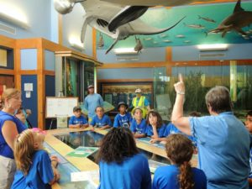](https://nsbfoundation.com/wp-content/uploads/2022/02/GTM-4.jpg)

Guana Tolomato Matanzas National Estuarine Research Reserve

[Guana Tolomato Matanzas National Estuarine Research Reserve](https://gtmnerr.org/) – Protecting 76,760 acres, the GTM Research Reserve is committed to the conservation of natural biodiversity and cultural resources through research. These protected areas provide a habitat for a variety of fish and wildlife and nearly 10 miles of trails for walking, hiking, biking, horseback riding, dog walking, nature viewing, and picnicking. Horses and leashed pets are allowed on the Guana Ponte Vedra Beach trails. Be sure to snap a photo at the statue of Juan Ponce de Leon!

Vilano Beach – Vilano Beach serves as one of the two Atlantic inlets on A1A Scenic & Historic Coastal Byway, creating a perfect place to search for shark’s teeth. Known for outdoor recreation, it is also home to the byway’s only Florida ‘Trail Town’.

[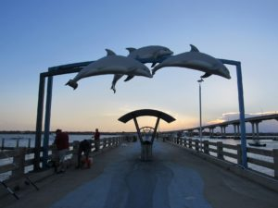](https://nsbfoundation.com/wp-content/uploads/2022/02/Vilano-Beach-Pier-cc-2-1.jpg)

Vilano Beach Pier

“Old Florida” emerges in Vilano Beach, offering guests a laid-back vibe.

***What to Experience:***

* [North Beach Pavilion & Park](https://www.historiccoastculture.com/venue/north-beach-pavilion-park/) – Just north of Vilano Beach, this park is perfect for an entire day of fun, with free parking, a beach walkover, restrooms, showers, a playground, picnic pavilion and grills. This popular location is known as the “love bridge” with locks decorating the walkway over A1A.
* [Vilano Beach Nature Boardwalk](https://www.historiccoastculture.com/venue/vilano-beach-nature-boardwalk/) – a quarter-mile boardwalk with scenic salt marsh views. See beautiful wildlife mosaics as you access the Vilano Bridge.
* [Airstream Row](https://www.historiccoastculture.com/venue/airstream-row-at-vilano-beach/) – shop for one-of-a-kind antiques, and discover unique finds from boutique retailers and local makers.

***Where to Eat & Drink:***

* Cap’s on the Water – enjoy fresh seafood and gorgeous sunsets from Cap’s expansive, waterfront decks. Indoor and outdoor dining.
* The Reef – just north of Vilano Beach on A1A, overlooking the Atlantic Ocean. Fresh seafood and both indoor and outdoor oceanfront dining.
* Beaches Restaurant – Downtown Vilano Beach; casual. American cuisine, fresh seafood. Overlooks Intracoastal Waterway with a stunning view of St. Augustine.
* Pesca by Michael’s – Downtown Vilano Beach, Latin American cuisine, coming 2022. Upscale. Rooftop dining.

[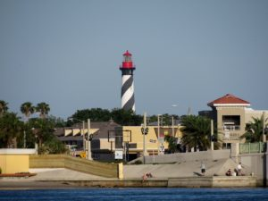](https://nsbfoundation.com/wp-content/uploads/2022/02/St-Augustine-Lighthouse-cc.jpg)

St. Augustine Lighthouse

[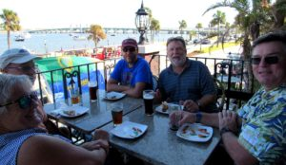](https://nsbfoundation.com/wp-content/uploads/2022/02/Bridge-of-Lions-B.jpg)

Bridge of Lions

[St. Augustine](https://www.historiccoastculture.com/travel-itineraries/guide-downtown-st-augustine/) – St. Augustine offers a European feel and is unlike any other place in America. The nation’s oldest city, continuously occupied since 1565, offers an unsurpassed collection of historic sites and cultural experiences, surrounded by scenic beauty.  Old and new discoveries are around every corner, with incredible views of the Matanzas River and historic Bridge of Lions, brick-lined streets filled with shops, galleries, restaurants, and bars, and a thriving music and visual arts scene.  World-renowned chefs create flavorful combinations in atmospheric restaurants that mix old-world charm with new-world cuisine.

***What to Experience:***

* [Castillo de San Marcos](https://www.historiccoastculture.com/venue/castillo-de-san-marcos/) – the oldest masonry fort in the continental United States, completed in 1695, and never conquered
* Aviles Street – Explore America’s oldest street, complete with restaurants, galleries, and historic museums.
* Uptown Shops and Restaurants – just north of the Castillo on San Marco Boulevard is St. Augustine’s premier shopping area, with several blocks of outstanding boutiques featuring home décor, clothing, art, and antiques. Several excellent cafes are located in this area, along with Carrera Wine Seller, a wine shop with tasting rooms.
* George Street – This pedestrian-only, historic avenue is full of dining and entertainment options and includes an assortment of unique gift shops in downtown St. Augustine.
* Colonial Quarter – Centuries of St. Augustine’s history comes to life at the [Colonial Quarter](http://colonialquarter.com/). Meet history interpreters, climb the 35-foot watchtower for bayfront views, and check out free concerts at [Colonial Oak Music Park](http://colonialquarter.com/music/), the largest outdoor venue in downtown St. Augustine.
* Lightner Museum – With three floors of special and permanent exhibitions in the historic Alcazar Hotel, the museum offers an expansive collection of decorative arts. See stained glass from Louis Comfort Tiffany and paintings from around the world.  Enjoy lunch onsite in the Alcazar Café, located in what was once the world’s largest indoor pool.
* Hotel Ponce de Leon – Designed by Carrere and Hastings and built by Henry Flagler in 1888 to become one of the most exclusive resorts of its day, [Historic Tours](https://legacy.flagler.edu/pages/tours) of the former Hotel Ponce de Leon highlight the architectural heritage of what is now Flagler College. See murals by George Maynard and the world’s largest stationery collection of Tiffany glass.

***Where to Eat & Drink:***

[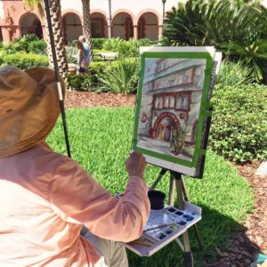](https://nsbfoundation.com/wp-content/uploads/2022/02/St-Augustine-Art-Association-A.jpg)

St. Augustine Art Association

[St. Augustine](https://www.historiccoastculture.com/travel-itineraries/guide-downtown-st-augustine/) is a food-lover’s dream with a diverse range of locally owned and operated restaurants. Blending ingredients sourced from St. Johns County farms and the hottest culinary trends, nationally celebrated chefs serve up once-in-a-lifetime dining experiences.

* Michael’s Tasting Room for Latin-inspired cuisine and outstanding steaks and seafood.
* The Floridian – an ode to Florida’s agricultural roots with good options for vegetarians
* Collage is a small, eclectic fine dining restaurant featuring a first-class, award-winning experience.
* Sunday is a great lunch/brunch spot with a bohemian feel, on San Marco Blvd. in the Uptown shopping district
* Looking for a cocktail or a craft beer?  Check out the Ice Plant, Boat Drinks or Dog Rose Brewing Company.  Visit Bog brewing on West King and the rooftop bars at Casa Reina and River and Fort.
* Live music can be heard throughout the streets, day and night, in places like Stogies, Tradewinds, and Prohibition Kitchen. Classical concerts are frequently offered in the Cathedral Basilica, and film, theatre, dance, and musical performances are regularly scheduled at Lewis Auditorium

**Anastasia Island,**[St. Augustine Beach](https://www.historiccoastculture.com/wp-content/uploads/sites/www.historiccoastculture.com/images/2021/01/neighborhoods-guide.pdf) & Beyond**–**Old Florida meets beach flair!  The area is home to a variety of restaurants, live music venues, America’s oldest port, and one of the nation’s top amphitheaters.

***What to Experience?***

* [Augustine Lighthouse & Maritime Museum](https://www.historiccoastculture.com/venue/st-augustine-lighthouse-museum/) Visit the restored Light Keeper’s house and climb to the top of the 1874 Lighthouse to see the breathtaking sights of St. Augustine from above. An educational museum explores lighthouse history and shipwreck archeology.  Additional exhibits feature artifacts and stories from WWII.
* The Amp – St. Augustine’s 4,000-seat Amphitheater, which plays host to internationally known musicians, special events and a weekly farmers markets, is ranked second among outdoor concert venues in the United States and third in the world, according to Pollstar Magazine.
* Augustine Alligator Farm Zoological Park – The whole family can have fun here enjoying a day packed with wildlife shows, zip lining and exotic animals. The Alligator Farm is the only place in the world where you can see every living crocodilian species!
* Fort Matanzas National Monument and Barrier Islands – Fort Matanzas National Monument preserves the fortified coquina watchtower, completed in 1742, which defended the southern approach to the Spanish military settlement of St. Augustine. You can explore the grounds by foot or water via the free ferry or by paddle board.
* [Johns County Pier](https://www.historiccoastculture.com/venue/st-johns-county-ocean-pier/) is just south of Anastasia State Park on A1A and offers pedestrian ramps, beach access, a splash park, a covered pavilion, showers, bathrooms and opportunities for sightseeing and fishing. Visit the site of wade-in demonstrations against segregation that led to passage of the 1964 Civil Rights Act and meet local artists at the St. Augustine Beach Art Studio and Wednesday market.

[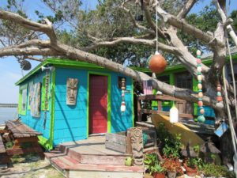](https://nsbfoundation.com/wp-content/uploads/2022/02/Crescent-Beach-3.jpg)

Crescent Beach

***Where to Eat & Drink?*** (From Anastasia Island to Crescent Beach)

* Planet Sarbez! – Grilled cheese and arcades, anyone? – Anastasia Island
* Llama Restaurant – Authentic Peruvian dining in a restaurant named one of the top 100 in the World by Open Table -Anastasia Island
* O’Steen’s Restaurant – Fresh seafood, casual. Cash only. While waiting, browse the antique store – Anastasia Island
* Old Coast Ales – delicious craft beers in a cool mid-century building; grab a taco next door at Osprey Taco – Anastasia Island
* Odd Birds – delicious craft cocktails and Latin cuisine – Anastasia Island
* Gas Full Service Restaurant – family friendly, casual spot featured on Food Network for their Jalapeño Popper Burger – Anastasia Island
* Beachcomber for fresh seafood steps from the beach – Augustine Beach
* Village Garden Food Truck Park – rotating selection of food truck fare – St. Augustine Beach
* Viola’s – authentic Italian – Crescent Beach
* Safe Harbor Seafood – Crescent Beach

**Matanzas Inlet**– Just 14 miles south of St. Augustine, lies the Matanzas Inlet, one of two Atlantic inlets on A1A Scenic & Historic Coastal Byway.  Enjoyed as a prime fishing spot, the inlet joins the Matanzas River to the Atlantic Ocean. Historically, the inlet was the location for the Spanish massacre of French forces in 1565 led by Pedro Menendez de Aviles. Today, there are miles of pristine beaches and lush hiking trails to explore. An excellent location for plein air artists and nature photographers.

Don’t miss Fort Matanzas National Monument, accessible only by ferry and the only Spanish colonial watchtower in the United States.

[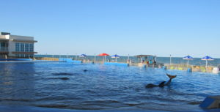](https://nsbfoundation.com/wp-content/uploads/2022/02/Marineland-3-scaled.jpg)

Marineland

**Marineland –**With a history dating back 1,400 years when the Native Americans began to live on the peninsula, Marineland provides inspiration and natural beauty.  Here, you can relax in the sun, swim with dolphins, assist in conservation projects, kayak through the estuaries or walk in the steps of the Timucuan Indians.

***What to Do?***

* [Marineland Dolphin Adventure](https://marineland.net/) – The world’s first oceanarium where you can swim with dolphins, see sea turtles and sand tiger sharks, immerse yourself in history and learn about conservation efforts.
* [The Sea Turtle Hospital at the University of Florida’s Whitney Laboratory](https://www.whitney.ufl.edu/conservation--sea-turtle-hospital/sea-turtle-hospital-tours/) – The Sea Turtle Hospital provides rehabilitation, education and research for sea turtle conservation. Private Behind the Scenes Tours are available

**Flagler Beach**

***What To Do?***

* [Washington Oaks Garden State Park](http://www.washingtonoaks.org/) – This Florida State Park sits along A1A in The Hammock, north of Flagler Beach and houses 20 acres of exquisite formal gardens. From 8 a.m. until sunset, you can also see the preservation of 425 acres of original habit of a northeast Florida barrier island.
* Flagler Beach Pier – Open daily 6 a.m. – midnight, the Flagler Beach Fishing Pier was built in 1928 and was 800 feet long. Storms have since changed that to 432 feet but haven’t changed the beautiful views as you walk along its path. A hot spot for anglers and surfers alike.
* [Flagler Beach Historical Museum](https://flaglerbeachmuseum.org/) – Located in the heart of Flagler Beach, the museum houses collections from pre-historic, Native American and colonial plantation artifacts to images of the town’s roaring 20’s, WWII encounters with German submarines and the world champion surfers of today. *Be sure to snap a photo with ‘Bessie’ a member of the Palm Coast Arts Foundation’s famed Turtle Trail. Link: https://www.palmcoastartsfoundation.com/the-turtle-trail-pcaf

**A1A Trip Planning Tools**

[Historic Coast Culture](https://www.historiccoastculture.com/travel-itineraries/) has a wide variety of itineraries and [tools](https://travelstorys.com/tours/a1a-scenic-byway) to help you plan your trip. The [A1A Scenic Byway Mobi Tour](https://travelstorys.com/tours/a1a-scenic-byway) is a great way to hear about must see stops on and near the byway.

*More Resources:*

Historic Coast Culture – [historiccoastculture.com](http://historiccoastculture.com/)

St. Johns Cultural Council: [www.stjohnsculture.com](http://www.stjohnsculture.com/)

A1A Scenic & Historic Coastal Byway: [www.scenica1a.org](http://www.scenica1a.org/)

A1A Scenic Byway Mobi Tour – <https://travelstorys.com/tours/a1a-scenic-byway>

**Now all that’s left is to hop in the car and get to exploring – A1A is waiting for you!**