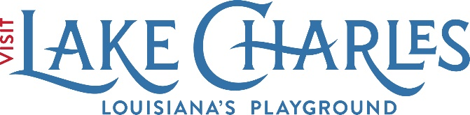

NEWS RELEASE    
For Immediate Release    
Contact:    
Candy Rodriguez

Director of Communications    
Visit Lake Charles    
337-502-4343

Mardi Gras Museum Breaks Ground in the Heart of the Nellie Lutcher Cultural District

LAKE CHARLES, La. (Oct. 1, 2024) — Today, the Mardi Gras Museum of Imperial Calcasieu officially broke ground on its new 6,000-square-foot, one-story building. The ceremony took place at 641 Enterprise Boulevard, in the heart of the Nellie Lutcher Cultural District, marking a significant step in the museum's redevelopment following Hurricane Laura.

“This new regional attraction will showcase and define Southwest Louisiana’s rich Mardi Gras culture,” said Kyle Edmiston, the president and CEO of Visit Lake Charles. “With its prime location near Interstate 10, the museum is expected to draw both locals and visitors to the Nellie Lutcher Cultural District.”

First announced in the spring of 2023, the new museum will showcase around 400 historic Mardi Gras costumes worn over the past 50 years, along with more than 15 animatronics that will guide visitors through the rich history of Mardi Gras. A new addition to the exhibits, Norah Jean, an animatronic talking dog representing the Krewe of Barkus, will offer a unique and entertaining perspective.

The museum will also contribute to the continuous economic renewal of the Nellie Lutcher Cultural District, a key focus of the Just Imagine SWLA 50-Year Resilience Master Plan for Calcasieu and Cameron Parishes.

“Mardi Gras holds a special place in our community’s heart,” expressed Mayor Nic Hunter of Lake Charles. “With the support of so many public and private partners, this project signifies a commitment to rebuilding and advancing cultural tourism in Lake Charles. We are especially thrilled to welcome this project to the Nellie Lutcher Cultural District. We thank Visit Lake Charles for their amazing efforts and look forward to this being yet another tangible example of the incredible growth we’ve seen in this district in recent years.”

To further support the museum’s development, the Board of Directors of The Mardi Gras Museum of Imperial Calcasieu is offering an opportunity for the public to contribute to its new interior by purchasing personalized bricks or tiles, with proceeds funding exhibits and preserving Mardi Gras history.

The museum is slated to open in late 2025, with an estimated cost of $3.5 million, funded through a combination of a grant from the U.S. Economic Development Administration (EDA) and local investments from the City of Lake Charles and Visit Lake Charles.

###

**About Visit Lake Charles:**

Visit Lake Charles, the official destination marketing organization for Lake Charles/Southwest Louisiana, is the only organization in Southwest Louisiana providing advocacy, promotion, and education for the tourism industry. For more information on Visit Lake Charles and things to see and do in Louisiana’s Playground, log on to www.visitlakecharles.org.